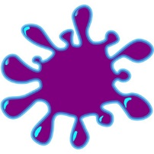

The Minnesota Local Section of the American Chemical Society is pleased to announce our upcoming event

Image result for slime free clipart **ACS Fall Family Day**

**An event specially put on for parents who are also chemists to share their love of chemistry with their children while networking with other, moms, dads, aunts, uncles and professionals in chemistry!**

Enjoy a fun filled afternoon with your children, grandchildren, nieces and nephews, or any other children in your life. The event will give children a chance to play and adults a chance to network with each other. The afternoon will have several fun and safe demos and activities your children can do on their own or with some help along with a bounce house. For a break, liquid nitrogen ice cream will be made and the event will close with a raffle of science related prizes!



**When:** Saturday, September 9th, 2023

2:45 – 3:00 pm: Arrival/Sign In

3:00 – 4:45 pm: Bounce house, playground, projects

3:45 – 4:00 pm: Liquid Nitrogen ice cream

4:15 – 4:30 pm: Raffle

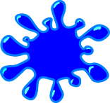

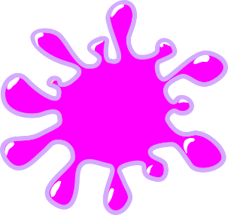**Where:** Mendakota Park – by playground  
2000 Mendakota Dr, Mendota Heights, MN 55120

**Ages:** Target age: around 2-12 years old

**Cost: Free: (Donations to project seed accepted)**

**RSVP:** Please RSVP by September 6th to **jwwollack@gmail.com**. Include number of children and adults will attend from your group.

Questions: Email James Wollack, [jwwollack@gmail.com](mailto:jwwollack@gmail.com).